CISC7204 Data Science and Data Visualization
Class E-Team 01-Group Photo

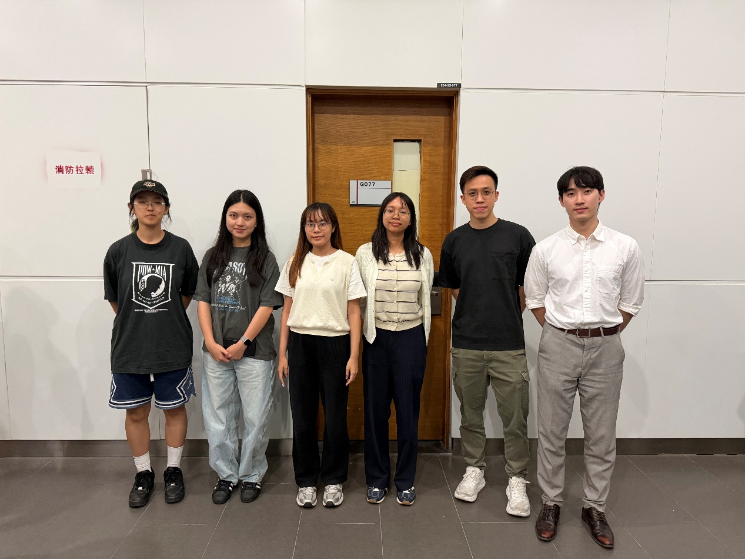
From Left to Right
- MC654992 SONG ZHUOXI
- MC642969 XIAN QILAN
- MC654953 FONG HIO LAM
- MC653748 FONG CHIN WAI
- MC653235 KUAN CHI KIT
- MC652817 KONG KIN MENG

